**Week 5 (ELECTRONICS):**

Two tasks for this week:

1-Design electric circuit that distributes DC voltage from 30V to 15V, 6V (do this using stepdown methods like a voltage regulator)

2-Design electric circuit that connects and disconnects motors from power source to not consume unused power (this is done using a transistor)

1-) I used a voltage regulator to lower the voltage. The voltage regulator was created using a diode and two resistors to turn 30V to 15V, then another diode and two resistors were used to turn 15V to 6.20V.

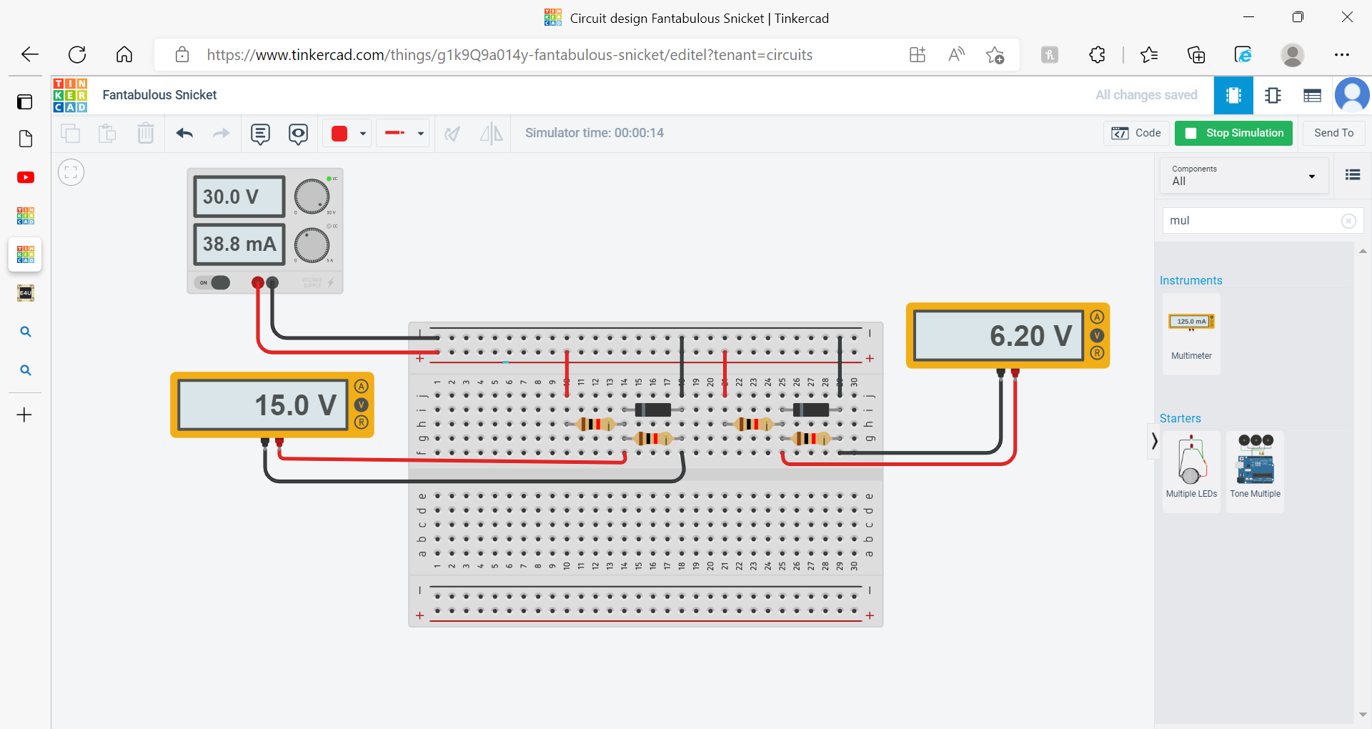

2-) I used a transistor to connect/disconnect power from the motor. 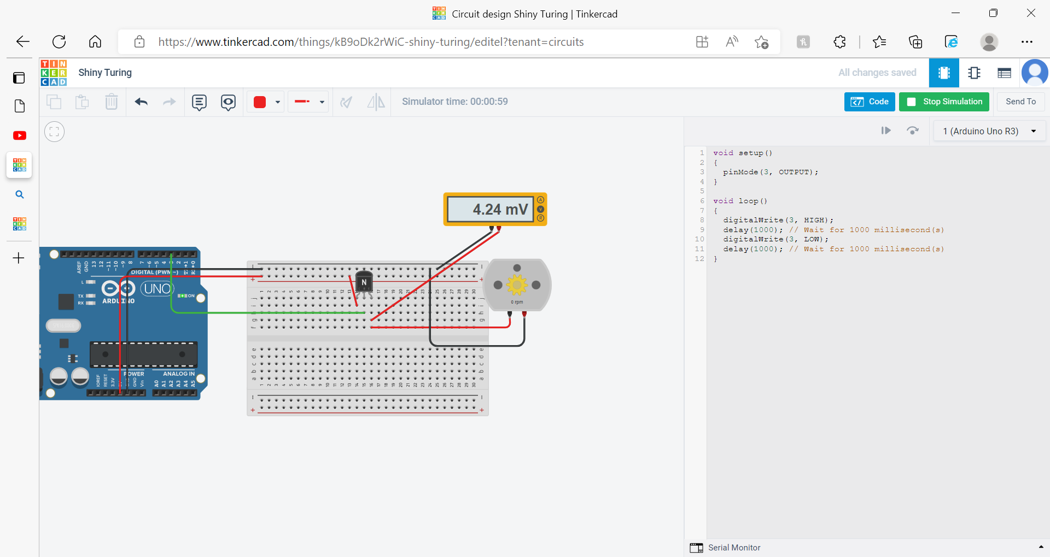

(this is the code)

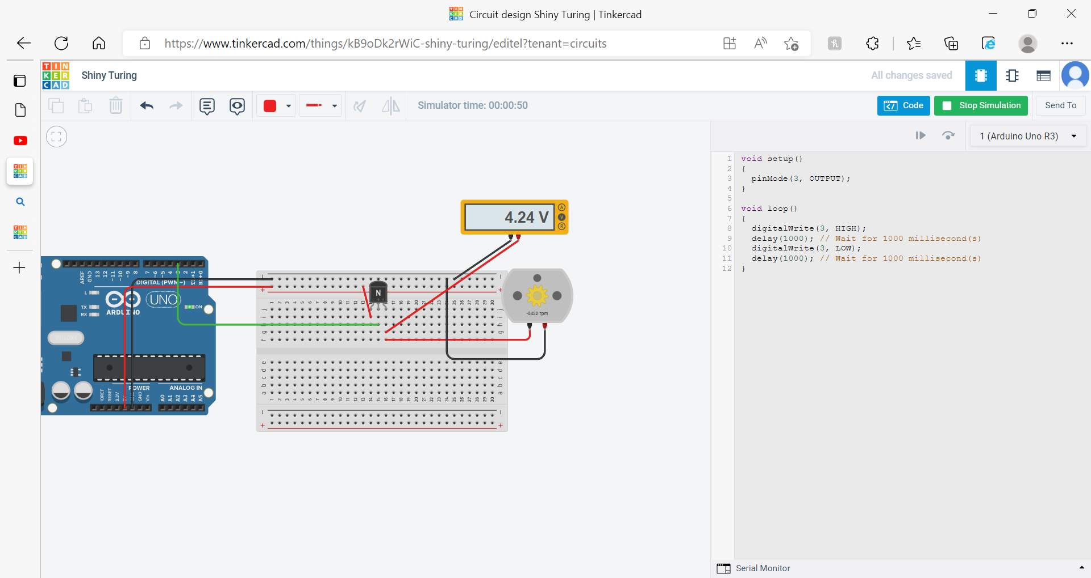

(The circuit is connected to a power source, and the motor is using power)

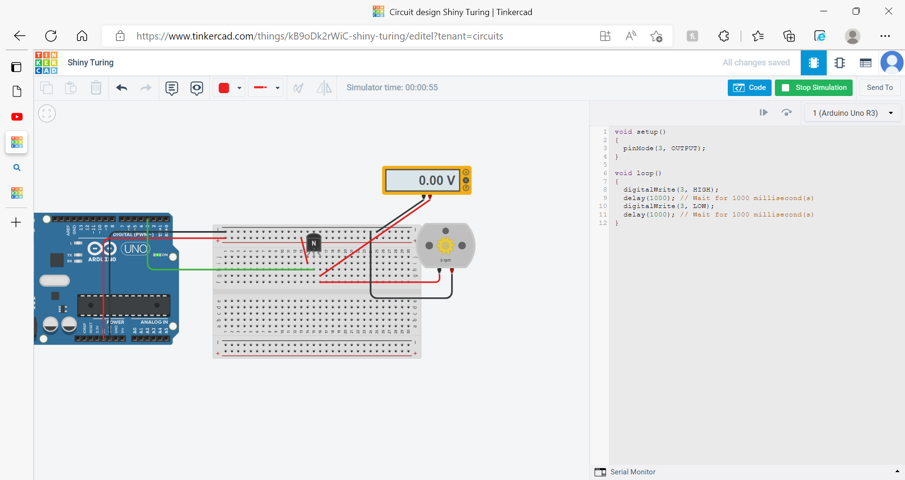

(The circuit is connected to a power source; the motor is not using power so the transistor prevents any current reaching the motor)